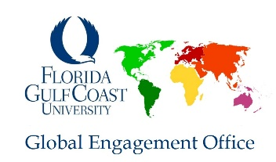
International Students Guide for on campus Employment at Compass USA

(Some procedures may have changed. Please contact the department you will be working for directly if you have any questions about the hiring process)

- Apply to the position that is posted.
Compass USA is the food service company on campus as of Fall 2022.
In order to apply to certain positions, we recommend that you check with the manager or supervisor of the cafe you would like to work with for application form or more information on the job. We also recommend stopping by their office at Cohen Student Union for more information.
https://dineoncampus.com/fgcu/job-opportunities

- Let your Supervisor know you have applied.

- Contact the Global Engagement office and let them know that you have been offered a job on campus and they will help guide you with making an appointment to apply for a social security card

- Check your email for ‘Offer Letter’ to accept.

- Make an appointment with the Global Engagement Office to pick up your letter to take to Social Security

- A Background Check is generated and sent to your Email (same one you applied with). Please open this email and complete the required information. Check Spam if necessary.

- Bring all I-9 Identification to FGCU Human Resources (see #3 Above or confirm items to bring to Human Resources) as soon as you have completed your Background Check, no appointment necessary.
  - Passport & Visa
  - I-20
  - I-94
  - Social Security Card (See # 3 above)

- Human Resources must inform you and your supervisor that you are cleared to work. Only when this clearance is given will you be allowed to attending trainings and meetings.

