Honors College Contract Proposal Form Guidance
The student fills out this section, “Honors Contract Proposal.” After the student fills out this preliminary information, an email is sent to the instructor with a link to the next section, “Honors Contract Proposal Detailed Information.”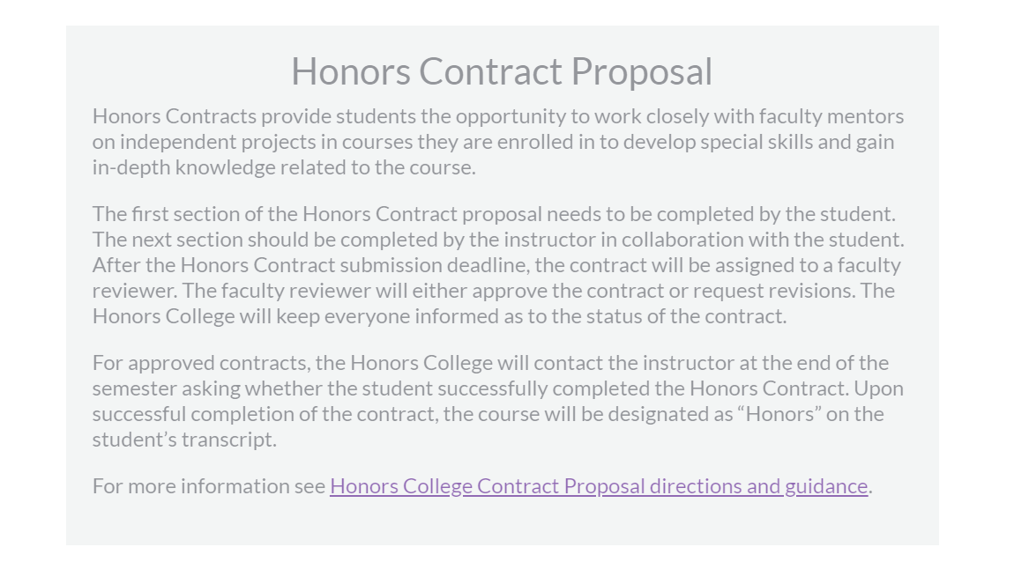
*Instructors, if you have not made an account with Formstack, you will not be able to complete the contract. The student will receive an error when they try to submit the first step if the instructor does not have an account with Formstack. Please email honors@fgcu.edu so we can get you set up with a Formstack account.*
When you are in Formstack, you can click any contract proposals here. If you are working on more than one contract, they will all be here in your workspace.
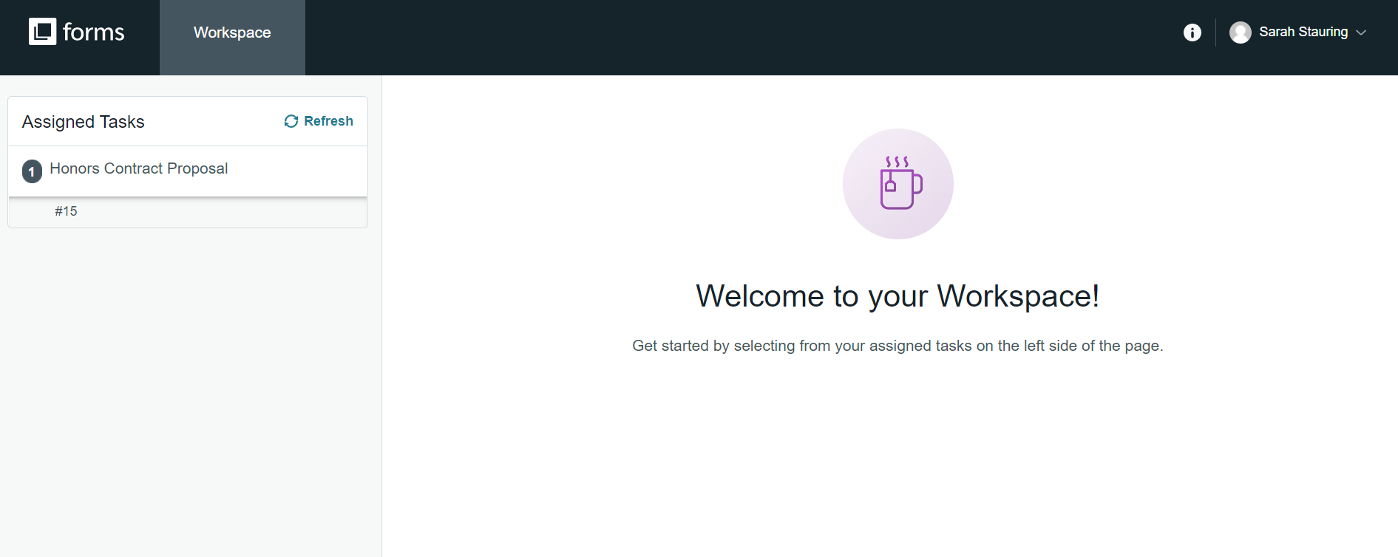
The instructor and student should work together to fill in the information in this section, “Honors Contract Proposal Detailed Information.” The instructor may have to log into Formstack for this step. Please make sure you have your password saved. Email honors@fgcu.edu for questions/concerns.
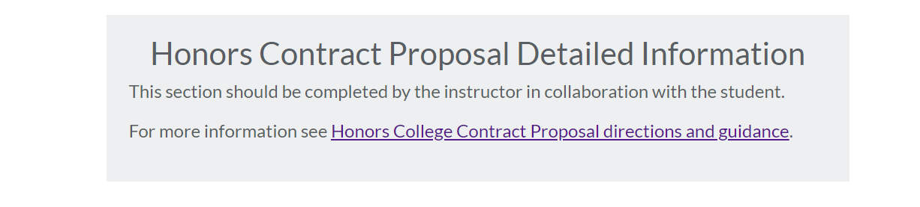
The proposal is sent to a faculty reviewer after the Honors Contract submission deadline. After faculty review:
- Revisions requested: The instructor will receive emails from noreply@formstack.com if revisions are requested. Instructor should work with student to make revisions. Revisions are made in the “Honors Contract Proposal Detailed Information” section.
- Not approved: The instructor will receive an email from “Honors College noreply+cc1f559432bca6f0@formstack.com” if the contract is not approved. If the contract is not approved, the student and instructor are encouraged to contact the Honors College for further guidance, at honors@fgcu.edu.
- Approved: The instructor and student will receive an email from honors@fgcu.edu with the approved contract information.

